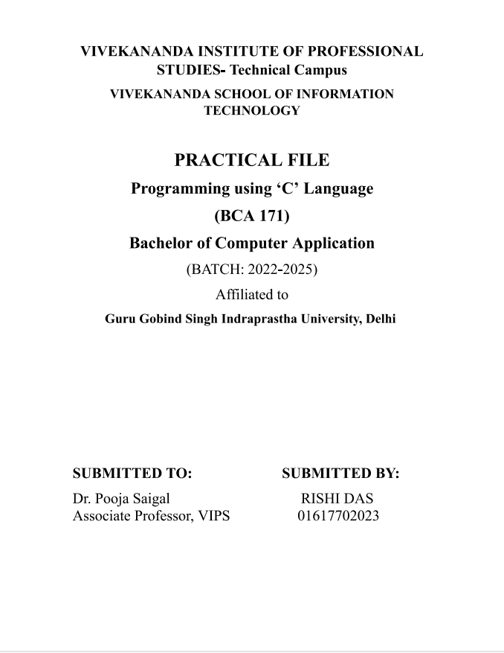



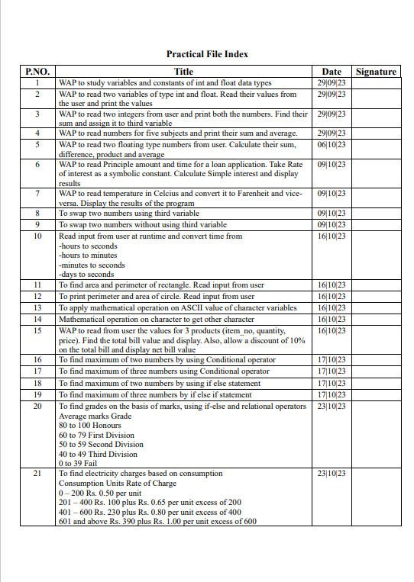

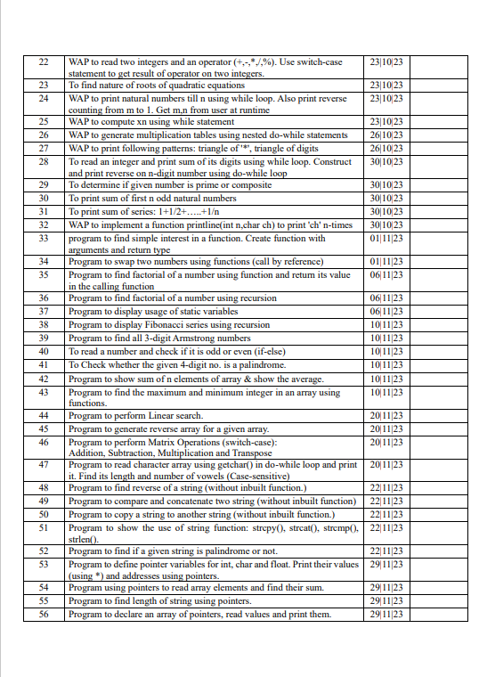

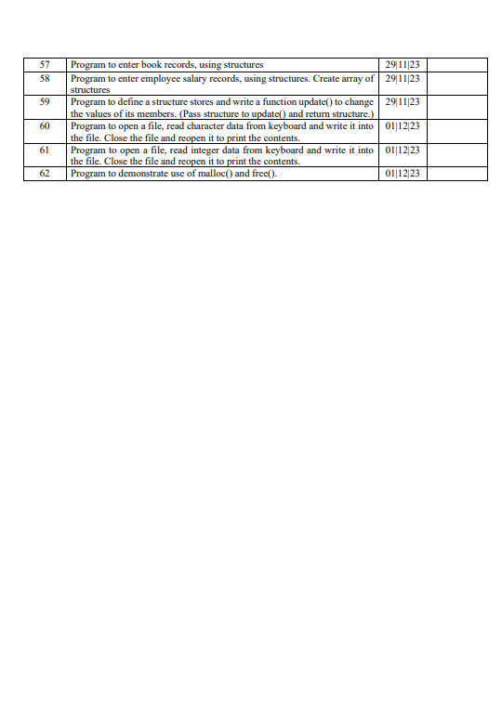

**PROGRAM 1**

**WAP to study variables and constant of int and float data types.**

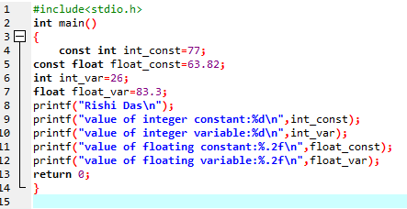

**Output:**

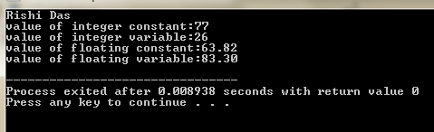

**Practical 2: WAP to read two variables of type int and float.Read their values from the user and print the values**

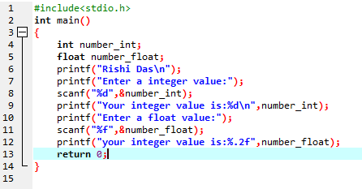

**Output :**

**Practical 3: WAP to read two integers from user and print both the numbers.Find their sum and assign it to third variable.**

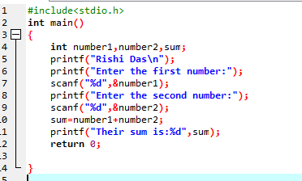

**OUTPUT**

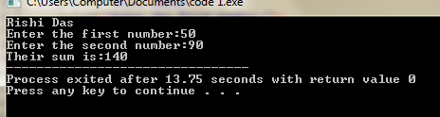

**PROGRAM 4:WAP to read numbers for five subjects and print their sum and average**

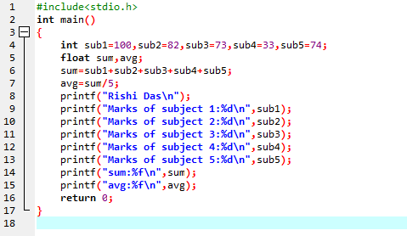

**Output:**

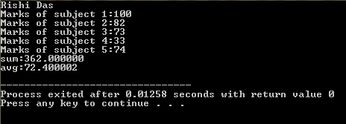

**PROGRAM 5.WAP to read two floating type numbers from user.Calculate their sum,difference,product and average**

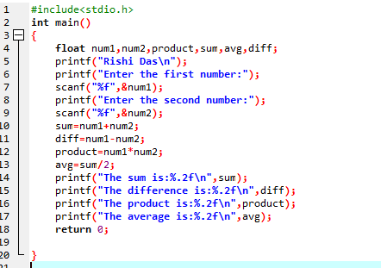

**OUTPUT :**

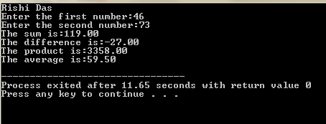

**PROGRAM 6: WAP to read principle amount and time for loan application.Take rate of interest as a symbolic constant.Calculate simple interest and display results.**

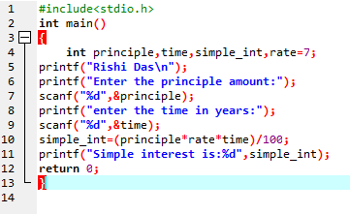

**OUTPUT:**

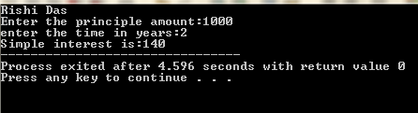

**PROGRAM 7:WAP to read temperature in celcius and convert it to Farenheit and vice versa.Display the results of the program.**

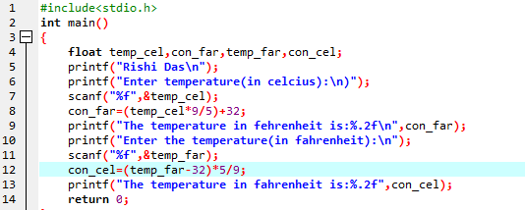

**OUTPUT:**

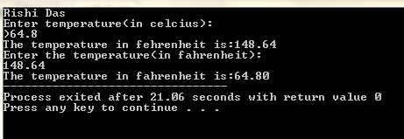

**PROGRAM 8: To swap two numbers using third variable.**

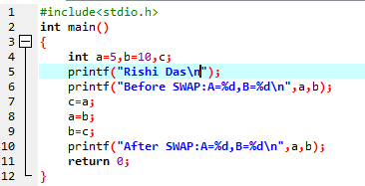

**OUTPUT:**

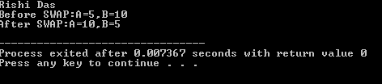

**PROGRAM 9: To swap two numbers without using third variable.**

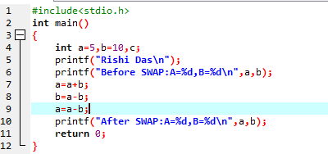

**OUTPUT:**

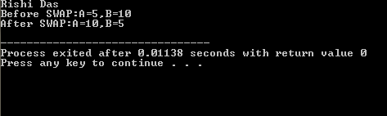

**#PROGRAM 10**

(Wap to read input from user at runtime and convert time from hours to seconds ,hours to minutes ,minutes to seconds ,days to seconds)

**#include<stdio.h>**

**int main()**

**{**

**int minute,days,hours;**

**printf("Rishi Das\n");**

**printf("Enter days:");**

**scanf("%d",&days);**

**printf("Enter minute:");**

**scanf("%d",&minute);**

**printf("Enter hours:");**

**scanf("%d",&hours);**

**printf("Days to second=%d seconds\n",days*24*3600);**

**printf("hours to second=%d seconds\n",hours*3600);**

**printf("minute to second=%d seconds\n",minute*60);**

**printf("hours to minute=%d minute\n",hours*60);**

**return 0;**

**}**

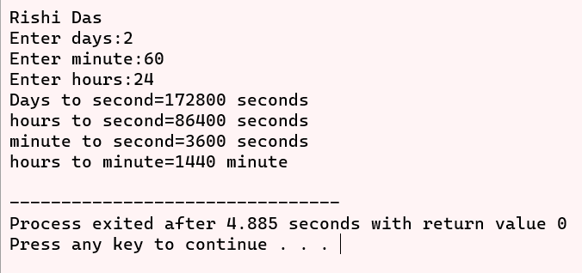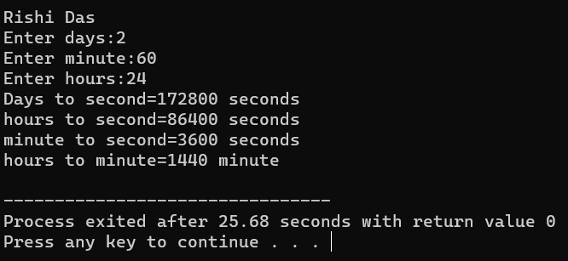

**#PROGRAM 11**

(wap To find area and perimeter of rectangle. Read input from user)

**#include<stdio.h>**

**int main()**

**{**

**int l,b,a,p;**

**printf("Rishi das\n");**

**printf("ENTER THE LENGTH AND BREADTH OF RECTANGLE RESPECTIVELY:");**

**scanf("%d%d", &l,&b);**

**a=l*b;**

**p=2*(l+b);**

**printf("AREA OF RECTANGLE IS:%d\n",a);**

**printf("PERIMETER OF RECTANGLE IS:%d\n",p);**

**return 0;**

**}**

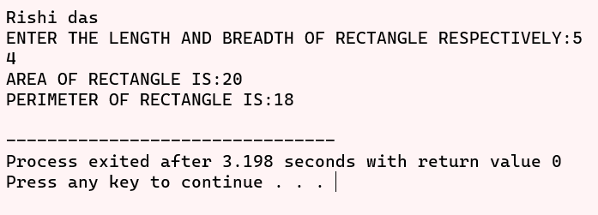

**#PROGRAM 12**

(wap to print perimeter and area of circle. Read input from user)

#include<stdio.h>

#define PI 3.14

int main()

{

float r,a,p;

printf("Rishi das\n");

printf("ENTER THE RADIUS OF THE CIRCLE:");

scanf("%f", &r);

a=PI*r*r;

p=2*PI*r;

printf("AREA OF CIRCLE IS:%.2f\n",a);

printf("PERIMETER OF CIRCLE IS:%.2f\n",p);

return 0;

}

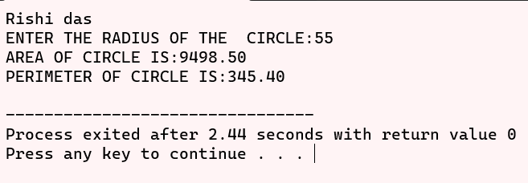

**#PROGRAM 13**

(wap To apply mathematical operation on ASCII value of character variables)

#include<stdio.h>

int main()

{

char a,b;

printf("Rishi das");

printf("\nEnter the character: "); scanf("%c %c",&a,&b);

printf("\nThe ASCII value of %c is %d",a,a);

printf("\nThe ASCII value of %c is %d",b,b);

printf("\nThe Sum is %c And the ASCII value of sum is %d",a+b,a+b);

printf("\nThe Sum is %c And the ASCII value of sum is %d",a+5,a+5);

printf("\nThe Sum is %c And the ASCII value of sum is %d",a-3,a-3);

printf("\nThe Sum is %c And the ASCII value of sum is %d",a-2,a-2);

return 0;

}

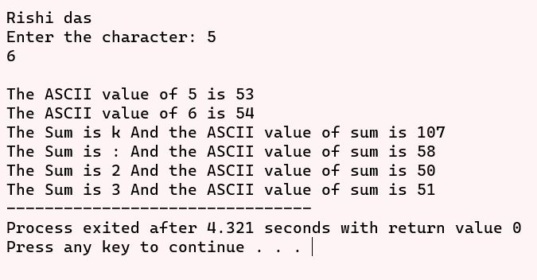

**#PROGRAM 14**

(Wap to mathematical operation on character to get other character)

#include<stdio.h>

int main()

{

char a,b,c,d,e,f;

printf("Rishi das\n");

printf("Enter two numbers: ");

scanf("%c %c",&a,&b);

c=a+b;

printf("\nThe ASCII equivalent for the sum of %c and %c is %c",a,b,c); d=a-b;

printf("\nThe ASCII equivalent for the sum of %c and %c is %c",a,b,d); e=a*b;

printf("\nThe ASCII equivalent for the sum of %c and %c is %c",a,b,e); f=a/b;

printf("\nThe ASCII equivalent for the sum of %c and %c is %c",a,b,f);

return 0;

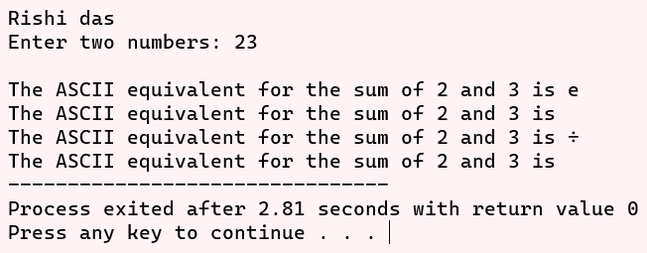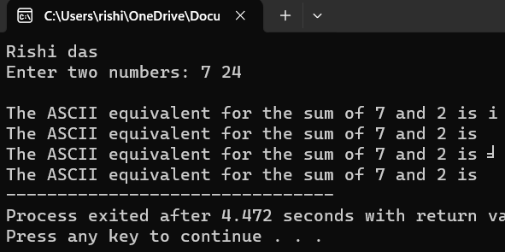}

**#PROGRAM 15**

(Wap to read from user the values for 3 products (item_no., quantity, price). Find the total bill value and display. Also, allow a discount of 10% on the total bill and display net bill value)

#include <stdio.h>

int main()

{

int x,y,z,a,b,c,tp,dis,p;

printf("Rishi das\n");

printf("\n NUMBER OF ITEMS BOUGHT (item 101)");

scanf("%d",&x);

printf("\n NUMBER OF ITEMS BOUGHT (item 102)");

scanf("%d",&y);

printf("\n NUMBER OF ITEMS BOUGHT (item 103)");

scanf("%d",&z);

a=x*25;

b=y*10;

c=z*100;

tp=a+b+c;

dis=tp/10;

p=tp-dis;

printf("BILL");

printf("\n___________________________________________________________________________");

printf("\n item no. quantity price per unit price");

printf("\n___________________________________________________________________________");

printf("\n 101 %d 35 %d" ,x,a);

printf("\n 102 %d 10 %d" ,y,b);

printf("\n 103 %d 60 %d" ,z,c);

printf("\n___________________________________________________________________________");

printf("\n total price %d" ,tp);

printf("\n discount(10%) %d",dis);

printf("\n total price %d" ,p);

return 0;

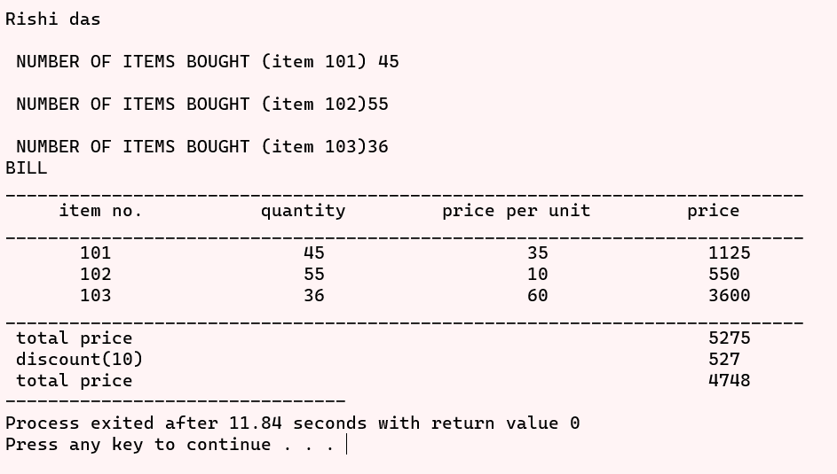}

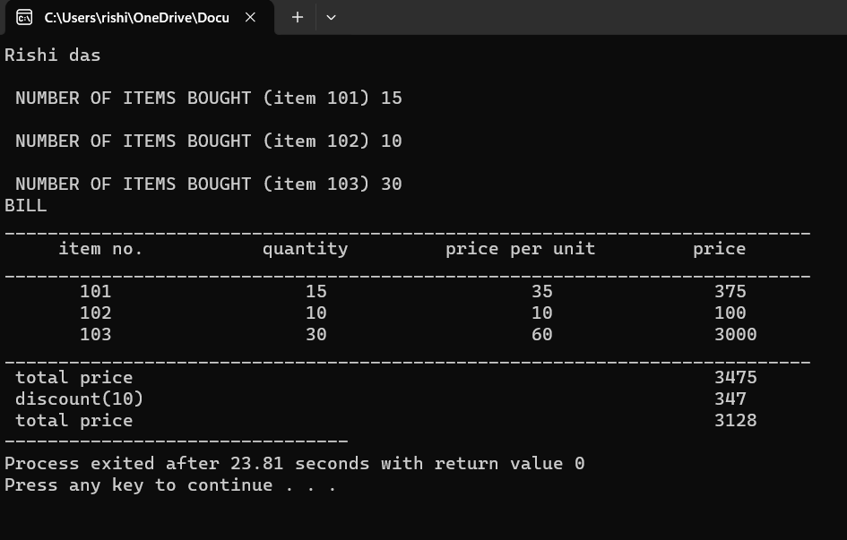

**#PROGRAM 16**

(Enter two variable and find the greatest number by conditional operator)

#include<stdio.h> int main()

int main()

{

int a,b,j;

printf("Rishi das\n");

printf("Enter the two numbers:");

scanf("%d%d",&a,&b);

j=(a>b)? a:b;

printf("The greatest number is %d",j);

return 0;

}

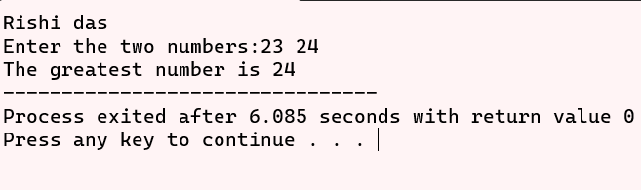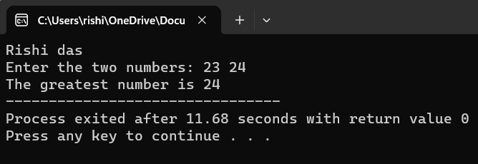

**#PROGRAM 17**

(wap to find maximum of three numbers using Conditional operator)

#include<stdio.h>

int main()

{

int a,b,c,g;

printf("Rishi das\n");

printf("Enter the three numbers");

scanf("%d%d%d",&a,&b,&c);

g=(a>b)? ((a>c)? a:c) : ((b>c)? b:c);

printf("The greatest number is %d",g);

return 0;

}

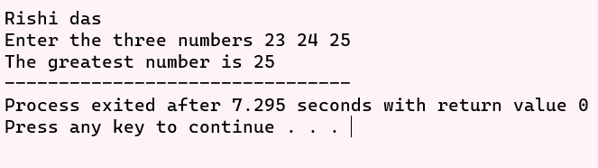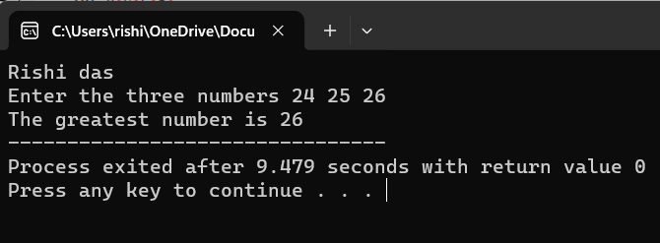

**#PROGRAM 18**

(wap to find maximum of two numbers by using if else statement)  
#include<stdio.h>

int main()

{

int a,b;

printf("Rishi das\n");

printf("ENTER TWO NUMBERS");

scanf("%d%d",&a,&b);

if (a>b)

printf("%d is greater" ,a);

else

printf("%d is greater",b);

return 0;

}

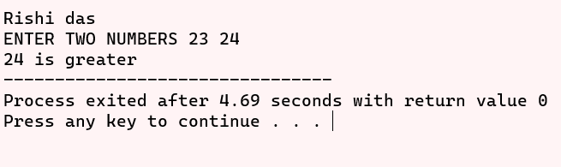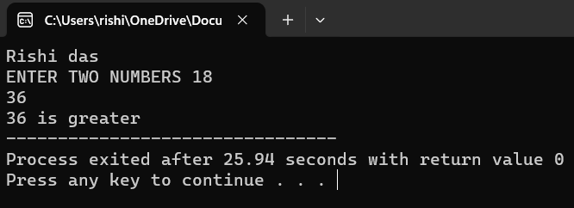

**#PROGRAM 19**

(wap to find maximum of three numbers by if else if statement)

#include<stdio.h>

int main()

{

int a,b,c;

printf("Rishi das\n");

printf("ENTER THREE NUMBERS\n");

scanf("%d%d%d",&a,&b,&c);

if (a>b)

if (a>c)

printf("%d is greatest",a);

else

printf("%d is greatest",c);

else

if (b>c)

printf("%d is greatest",b);

else

printf("%d is greatest",c);

return 0;

}

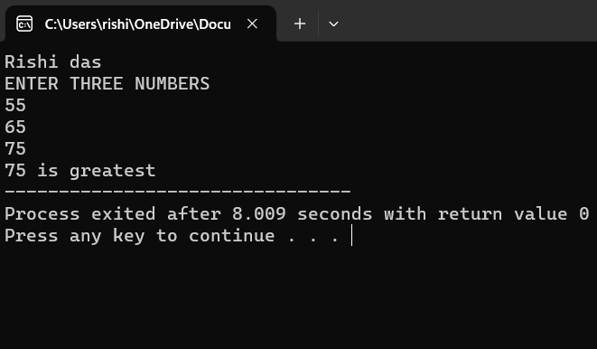

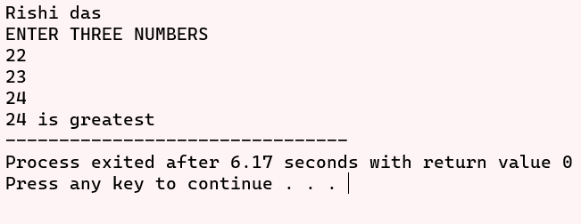

**#PROGRAM 20**

#include <stdio.h>

int main()

{

int a;

printf("Rishi das\n");

printf("ENTER MARKS\n");

scanf("%d",&a);

if (a>100)

printf("INVALID NUMBER"); //OUTPUT BELOW:

else if (a>=80)

printf("HONOURS");

else if (a>=60)

printf("FIRST DIVISON");

else if (a>=50)

printf("SECOND DIVISON");

else if (a>=40)

printf("THIRD DIVISON");

else

printf("YOU ARE FAILED\n");

return 0;

}

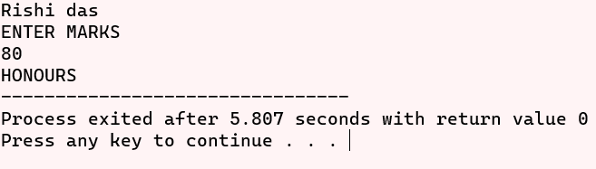

**#PROGRAM 21**

(wap To find the electricity charges based on consumption units rate of charge.)

#include<stdio.h>

int main()

{

float unit,charge;

printf("Rishi das\n");

printf("Enter the electricity unit of the house: ");

scanf("%f",&unit);

if(unit<=200)

charge=0.5;

else if(unit<=400)

charge = 100 + (unit-200)*0.65;

else if(unit<=600)

charge= 230 + (unit-400)*0.8;

else

charge= 390 + (unit-600)*1;

printf("\nCharge is %.2f", charge);

return 0;

}

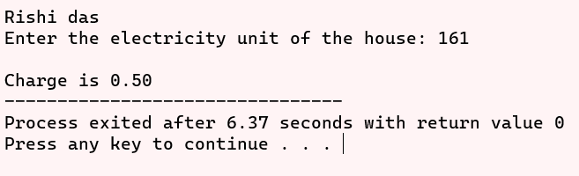

**#PROGRAM 22**

(Wap to read two integers and an operator (+, -, *, /). Use switch case statement to get the result of operator on two integers)

#include <stdio.h>

int main() {

printf("Rishi das\n");

char operand;

float first, second;

printf("Enter an operator (+, -, *, /): ");

scanf("%c", &operand);

printf("Enter two operands: ");

scanf("%f %f", &first, &second);

switch (operand) {

case '+':

printf("%.1f + %.1f = %.1f", first, second, first + second);

break;

case '-':

printf("%.1f - %.1f = %.1f", first, second, first - second);

break;

case '*':

printf("%.1f * %.1f = %.1f", first, second, first * second);

break;

case '/':

printf("%.1f / %.1f = %.1f", first, second, first / second);

break;

default:

printf("ENTER THE COORECT OPERAND(+,-,*,/)");

}

return 0;

}

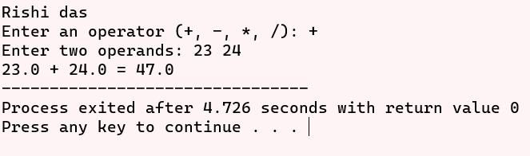

**#PROGRAM 23**

(wap to find the nature roots of quadratic equation)

#include<stdio.h>

#include<math.h>

int main()

{

float a,b,c,d,x,y;

printf("Rishi das");

printf("***************************************************\n");

printf("Enter the value of quadratic equation \n");

printf("a = ");

scanf("%f",&a);

printf("b = ");

scanf("%f",&b);

printf("c = ");

scanf("%f",&c);

d= (pow(b,2)-(4*a*c)); if (d<0);

{

printf("***************************************************\n");

printf("The given value has no roots");

printf("\n***************************************************\n");

}

if(d>0)

{

printf("****************************************************\n");

x = (-b+sqrt(d))/(2*a);

y= (-b-sqrt(d))/(2*a);

printf("The roots of quadratic equation is %.1f , %.1f",x,y);

printf("\n****************************************************\n");

}

else

{

printf("****************************************************\n");

x = (-b+sqrt(d))/(2*a);

y= (-b-sqrt(d))/(2*a);

printf("Given value has equal roots that is %.2f, %.2f",x,y); printf("\n***********************************************************\n");

}

return 0;

}

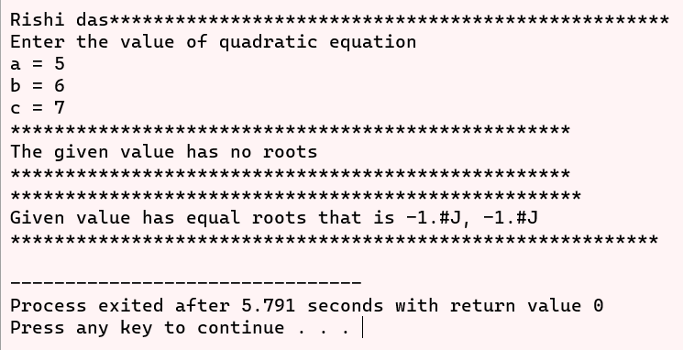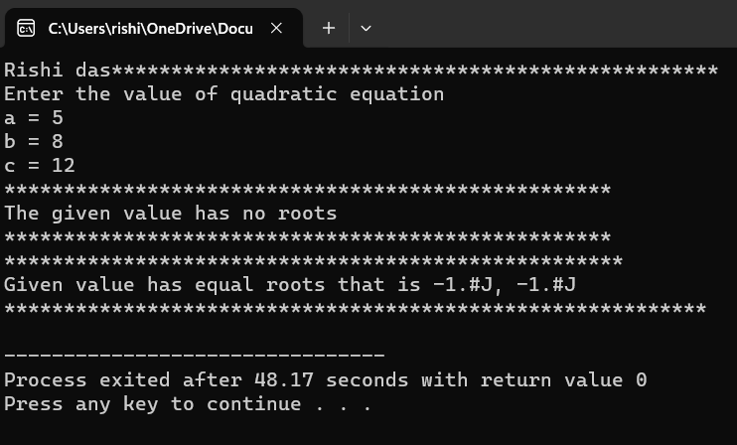

**#PROGRAM 24**

(Wap to print natural numbers till n using while loop. Also print reverse counting from m to 1. Get m and n from the user at a run time.)

#include <stdio.h>

int main()

{

printf("Rishi das\n");

int i,j,m,n;

printf("ENTER A DIGIT TILL YOU WANT TO PRINT:");

scanf("\n%d",&n);

i=1;

//loop for printing counting till n digit

while(i<=n)

{

printf("%d,",i);

i++;

}

printf("\nENTER A DIGIT:");

scanf("\n%d",&m);

j=m;

while(j>=1)

{

printf("%d,",j);

j--;

}

return 0;

}

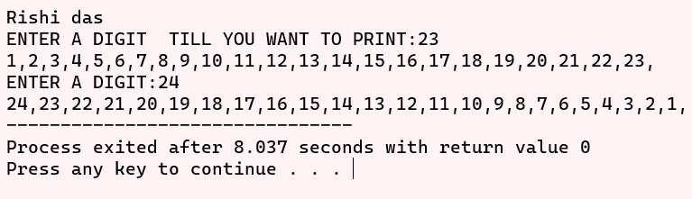

**#PROGRAM 25**

(Wap to compute xn using while statement.)

#include <stdio.h>

int main()

{

printf("Rishi das\n");

int base;

int exp;

int result=1;

printf("Enter a base number: ");

scanf("%d", &base);

printf("Enter an exponent: ");

scanf("%d", &exp);

while (exp !=0)

{

result=result*base;

exp--;

}

printf("ANSWER:%d",result);

return 0;

}

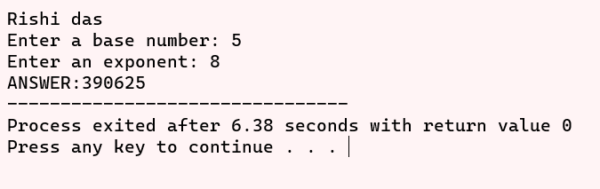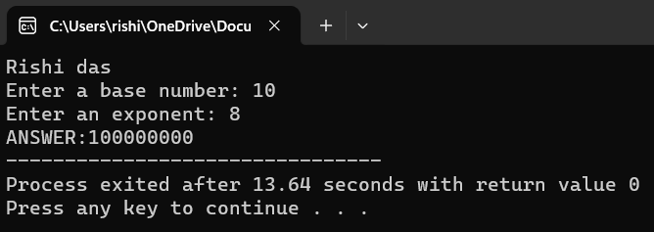

#PROGRAM 26

Wap to generate multiplication tables using nested do while statement.

#include<stdio.h>

int main()

{

int i,j,num;

printf("Rishi das\n");

printf("Enter the number till the multiplication table required");

scanf("%d",&num);

i=1;

do

{

j=1;

do

{

printf("%3d",i*j);

j++;

}while(j<=10);

printf("\n");

i++;

}while(i<=num);

return 0;

}

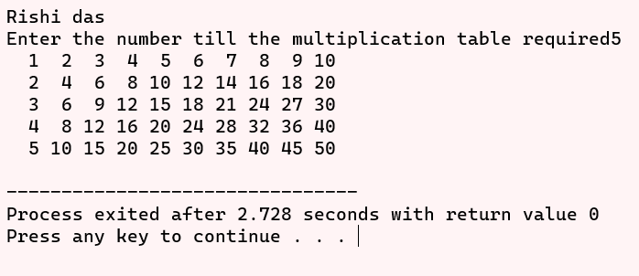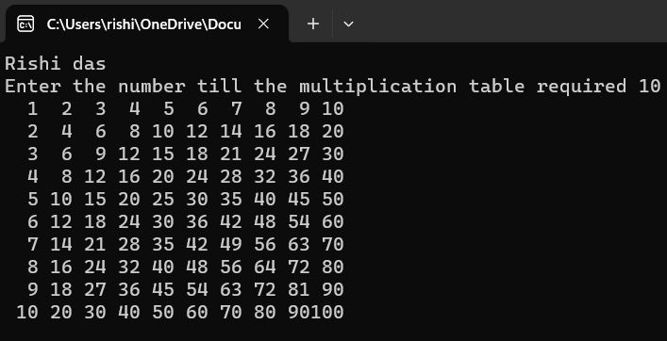

#PROGRAM 27

Wap to print following patterns: triangles of ‘*’, triangle of digits.

#include<stdio.h>

int main()

{

int row,i,j;

printf("Rishi das\n");

printf("Enter the number of rows");

scanf("%d",&row);

for(i=1;i<=row;i++)

{

for(j=1;j<=i;j++)

{

printf("*");

}

printf("\n");

}

printf("\n\n\n");

for(i=1;i<=row;i++)

{

for(j=1;j<=i;j++)

{

printf("%d",j);

}

printf("\n");

}

return 0;

}

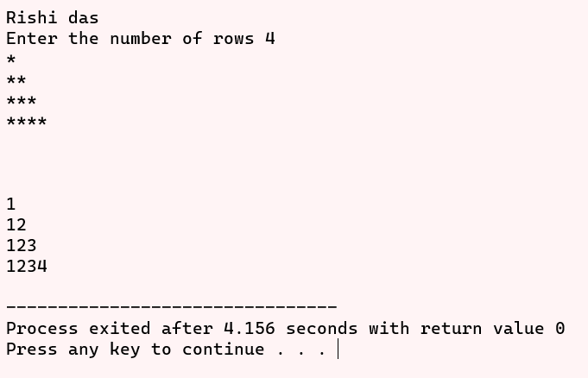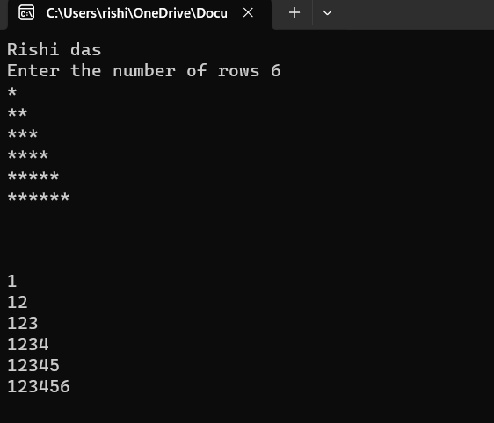

#PROGRAM 28

To read an integer and print sum of its digits using while loop. Construct and print reverse on n-digit number using do-while loop

#include<stdio.h>

int main()

{

int i,d=0,num,newm=0,sum=0,rev=0,o_num;

printf("Rishi das");

printf("\n-------------------------------\n");

printf("Enter the number: ");

scanf("%d",&num);

o_num=num;

while(num!=0)

{

newm=num%10;

sum+=newm;

num/=10;

d++;

}

printf("sum of digit %d\n",sum);

do

{

rev=rev*10+o_num%10;

o_num=o_num/10;

d++;

}

while(o_num!=0);

printf("Reverse number is %d",rev);

return 0;

}

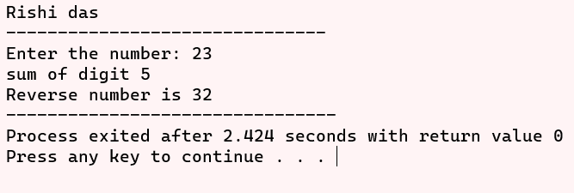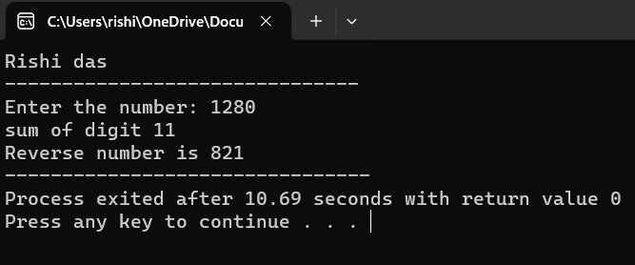

#PROGRAM 29

#include<stdio.h>

int main()

{

int i,num,n=0;

printf("Rishi das");

printf("\n-------------------------------\n");

printf("Enter any number: ");

scanf("%d",&num);

for (i=1; i<=num; i++)

{

if(num%i==0)

n++;

}

if (n==2)

printf("It is a prime number");

else

printf("It is a composite number");

return 0;

}

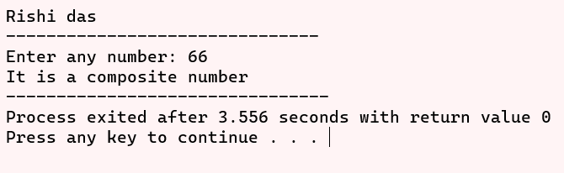

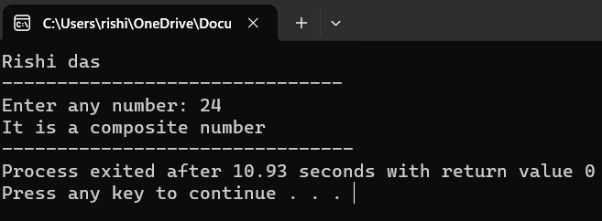

#PROGRAM 30

#include<stdio.h>

int main()

{

int sum=0,num,i;

printf("Rishi das");

printf("\n-------------------------------\n");

printf("Enter the number: ");

scanf("%d",&num);

for(i=1; i<=num; i++)

{

if(i%2==1)

sum+=i;

}

printf("sum is %d",sum);

return 0;

}

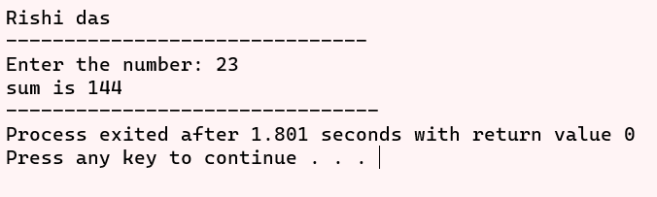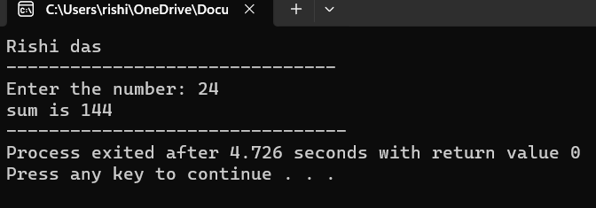

#PROGRAM 31

#include<stdio.h>

int main()

{

float sum=0,num,i;

printf("Rishi das");

printf("\n-------------------------------\n");

printf("Enter the number: ");

scanf("%f",&num);

for(i=1; i<=num; i++)

{

sum+=(1/i);

}

printf("sum is %.2f",sum);

return 0;

}

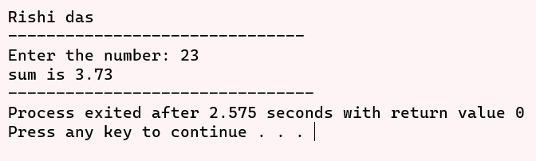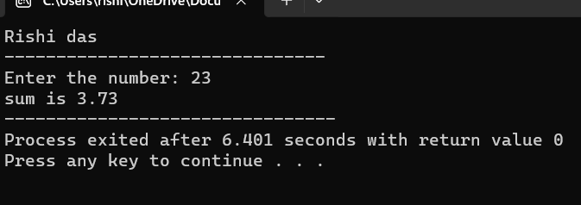

#PROGRAM 32

#include<stdio.h>

void printline(int n,int ch);

int main()

{

int ch,n;

printf("Rishi das");

printf("\n-------------------------------\n");

printf("Enter the number\n");

scanf("%d",&n);

printf("Enter the character\n");

scanf(" %c",&ch);

printline(n,ch);

return 0;

}

void printline(int k,int c)

{ int i;

for (i=1; i<=k; i++)

{ printf("%c ",c);

}

}

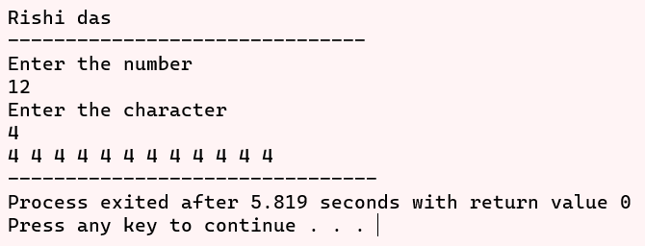

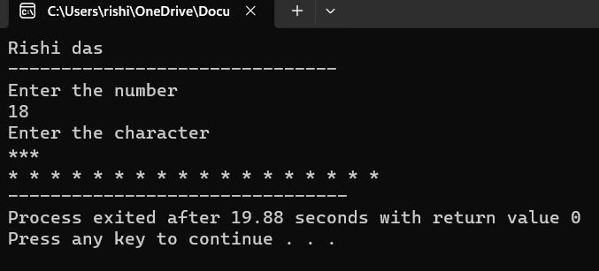

#PROGRAM 33

Program to find simple interest in a function create a function with argument and return type.

#include<stdio.h>

#define ROI 2

int si(int p, int t);

int main()

{

int principal,time;

printf("Rishi das\n");

printf("Enter the principal amount and time: - ");

scanf("%d %d",&principal,&time);

printf("Simple interest is %d\n",si(principal,time));

printf("Total amount is %d\n",principal+si(principal,time));

return 0;

}

int si(int p, int t)

{

return (p*ROI*t)/100;

}

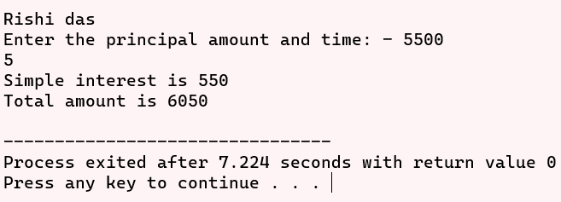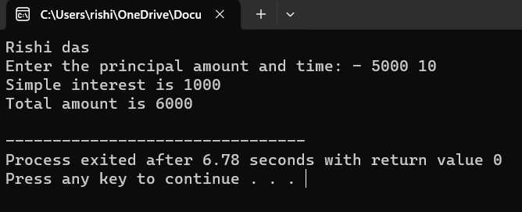

#PROGRAM 34

Program to swap two numbers using function (call by reference).

#include<stdio.h>

int main()

{

int n1,n2;

printf("Rishi das\n");

printf("Enter two numbers: - ");

scanf("%d %d",&n1,&n2);

printf("Before swapping number \nn1 is %d \nn2 is %d",n1,n2);

swap(&n1,&n2);

printf("\nAfter swapping number \nn1 is %d \nn2 is %d",n1,n2);

return 0;

}

void swap(int *a, int *b)

{

int temp;

temp = *a;

*a=*b;

*b=temp;

return;

}

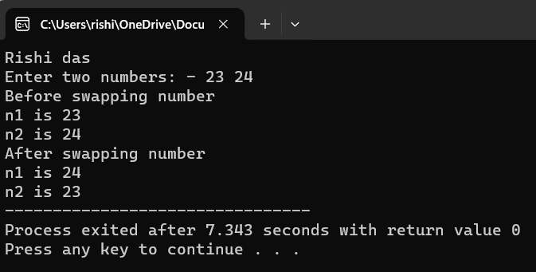

#PROGRAM 35

Program to find factorial of a number using function and return its value in the calling function .

#include<stdio.h>

int main()

{

int number;

printf("Rishi das\n");

printf("Enter the number for factorial: ");

scanf("%d",&number);

printf("\nFactorial of number %d is %d",number,fact(number));

return 0;

}

int fact(int num)

{

int i,fact=1;

for(i=num;i>=1;i--)

fact=fact*i;

return fact;

}

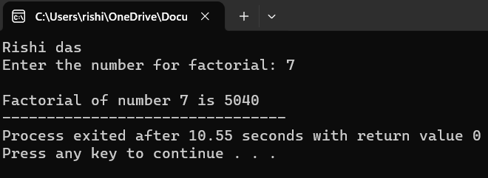

#PROGRAM 36

Program to find factorial of a number using recursion.

#include<stdio.h>

int fact(int num);

int main()

{

int number;

printf("Rishi das\n");

printf("Enter the number for factorial: ");

scanf("%d",&number);

printf("\nFactorial of number %d is %d",number,fact(number));

return 0;

}

int fact(int num)

{

if(num!=0)

return fact(num-1)*num;

else

return 1;

}

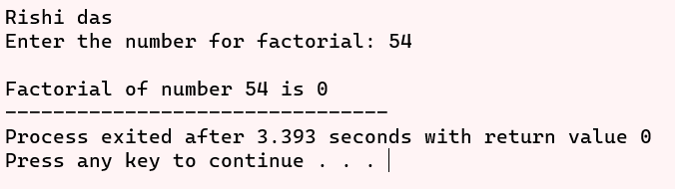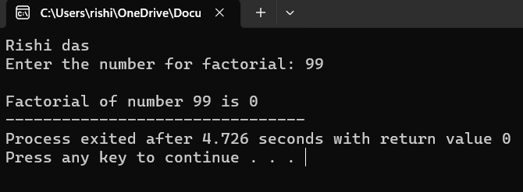

#PROGRAM 37

Program to display the usage of static variable.

#include<stdio.h>

int function();

int main()

{

int number;

printf("Rishi das\n");

printf("USage of static variable\n");

printf("a is %d",function());

printf("\na is %d",function());

return 0;

}

int function()

{

static int a=4;

a++;

return a;

}

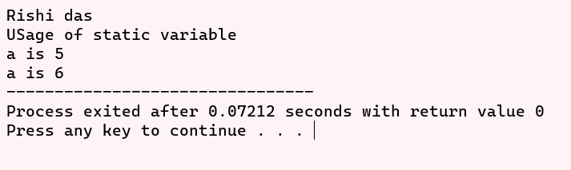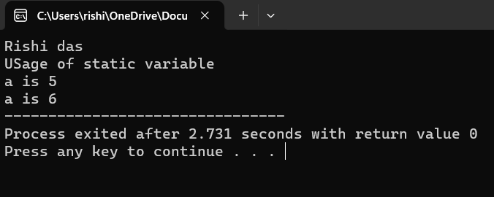

#PROGRAM 38

Program to display Fibonacci series using recursion.

#include<stdio.h>

int fib(int n);

int main()

{

int number,i;

printf("Rishi das\n");

printf("Enter the number til you want Fibonacci series: ");

scanf("%d",&number);

printf("The Fibonacci series:- ");

for(i=0; i<number; i++)

printf("%d ",fib(i));

return 0;

}

int fib(int n)

{

if (n==0)

return 0;

else if (n==1)

return 1;

else

return fib(n - 1) + fib(n - 2);

}

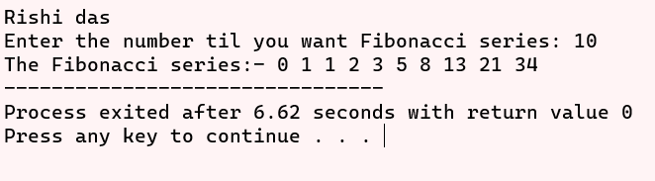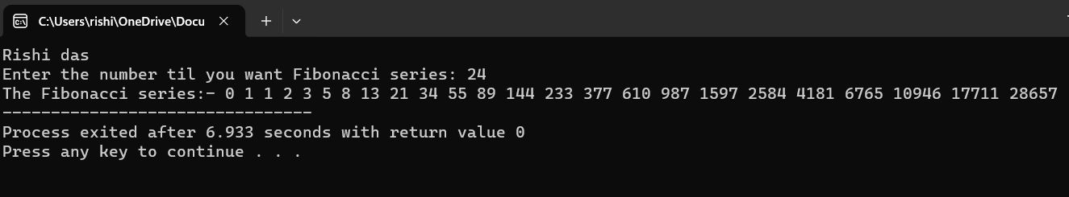

#PROGRAM 39

Program to find all 3-digit Armstrong numbers.

#include<stdio.h>

#include<math.h>

int arm(int num);

int main()

{

int i;

printf("Rishi das");

printf("\nArmstrong numbers are: ");

for(i=100;i<=999;i++)

arm(i);

return 0;

}

int arm(int num)

{

int o_num,a=0,s=0,d=0;

o_num=num;

while(num>0)

{

s=num%10;

a+=pow(s,3);

num=num/10;

d++;

}

if(a==o_num)

{

printf("%d ",o_num);

}

return 0;

}

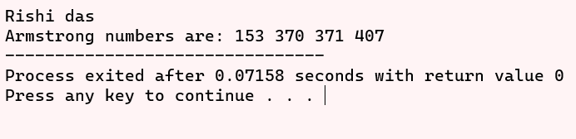

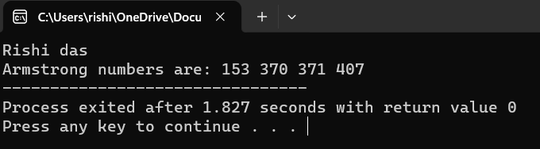

#PROGRAM 40

To read a number and check if it is odd or even (if-else).

#include<stdio.h>

void even(int n);

int main()

{

int num,i;

printf("Rishi das\n");

printf("Enter the number: ");

scanf("%d",&num);

even(num);

return 0;

}

void even(int n)

{

if(n%2==0)

printf("Number %d is even",n);

else

printf("Number %d is odd",n);

return;

}

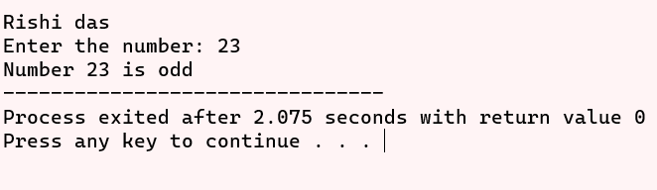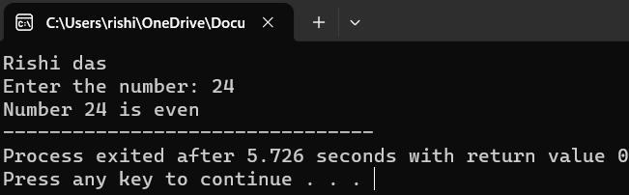

#PROGRAM 41

To Check whether the given 4-digit no. is a palindrome.

#include<stdio.h>

void palindrome(int n);

int main()

{

int num;

printf("Rishi das\n");

printf("Enter a number: ");

scanf("%d",&num);

palindrome(num);

return 0;

}

void palindrome(int n)

{

int o_num,rev=0;

o_num=n;

while(n>0)

{

rev=rev*10+n%10;

n=n/10;

}

if(rev==o_num)

{

printf("%d is a palindrome number\n\n",o_num);

}

else

{

printf("%d is not a palindrome number\n\n",o_num);

}

return ;

}

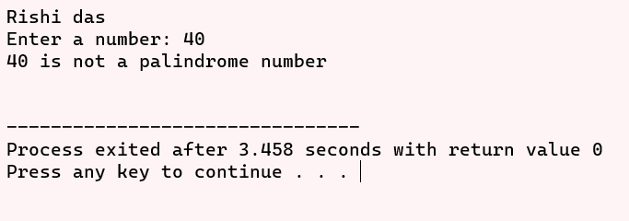

#PROGRAM 42

Program to show sum of n elements of array & show the average.

#include<stdio.h>

int main()

{

int n,i;

float sum=0,avg=0;

printf("Rishi das");

printf("\nEnter the size of array: ");

scanf("%d",&n);

float arr[n];

for (i=0;i<n;i++)

{

scanf("%f",&arr[i]);

sum+=arr[i];

}

avg=sum/n;

printf("Sum of array is %.1f\n",sum);

printf("Average of array is %.1f\n",avg);

return 0;

}

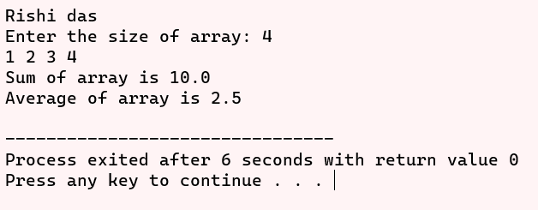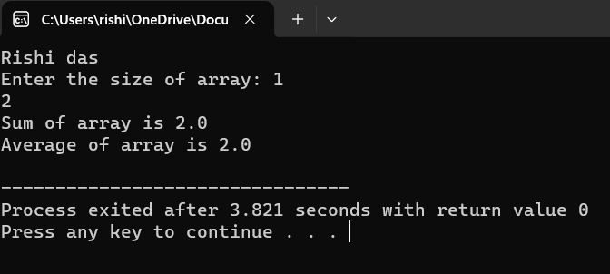

#PROGRAM 43

Program to find the maximum and minimum integer in an array using functions.

#include<stdio.h>

int maximum(int arr[],int n);

int minimum(int arr[],int n);

int main()

{

int n,i;

printf("Rishi das");

printf("\nEnter the size of array: ");

scanf("%d",&n);

int arr[n];

for (i=0;i<n;i++)

scanf("%d",&arr[i]);

printf("Maximum value is %d\n",maximum(arr,n));

printf("Minimum value is %d\n",minimum(arr,n));

return 0;

}

int maximum(int arr[],int n)

{

int i;

int max = arr[0];

for (i=0;i<n;i++)

{

if(max<=arr[i])

max=arr[i];

}

return max;

}

int minimum(int arr[],int n)

{

int i;

int min = arr[0];

for (i=0;i<n;i++)

{

if(min>=arr[i])

min=arr[i];

}

return min;

}

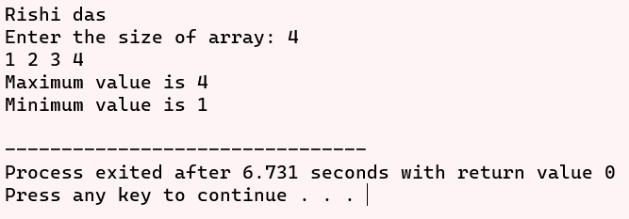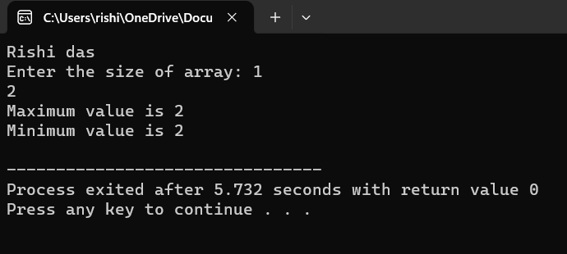

#PROGRAM 44

Program to perform Linear search

#include<stdio.h>

int main()

{

int n,item,i;

printf("Rishi Das\n");

printf("Enter the number of size in array: ");

scanf("%d",&n);

int arr[n];

for (int i=0;i<n;i++)

scanf("%d",&arr[i]);

printf("Enter the number to search: ");

scanf("%d",&item);

for(i=0;i<=n;i++)

{

if(item==arr[i])

{ printf("Search is successful\n");

printf("The number %d is available on index %d",item,i);

break;

}

if(i==n)

printf("The number %d is not available in array",item);

}

return 0;

}

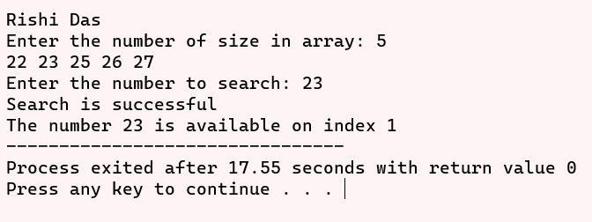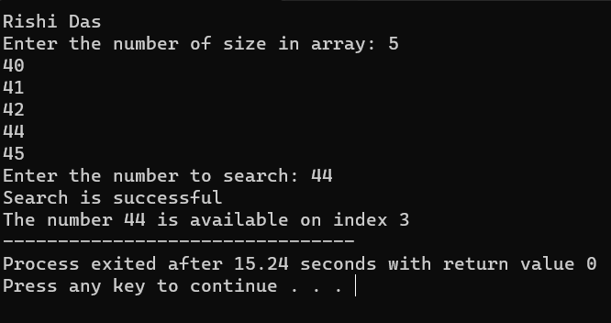

#PROGRAM 45

Program to generate reverse array for a given array

#include<stdio.h>

void reverse(int arr[], int n)

{

int i = 0;

int j = n-1;

while(i<j)

{

int temp = arr[i];

arr[i]=arr[j];

arr[j]=temp;

i++;

j--;

}

return;

}

int main()

{

int n;

printf("Rishi Das\n");

printf("Enter the number of size in array: ");

scanf("%d",&n);

int arr[n];

for (int i=0;i<n;i++)

scanf("%d",&arr[i]);

reverse(arr,n);

for (int i=0; i<n; i++)

{

printf("%d ",arr[i]);

}

return 0;

}

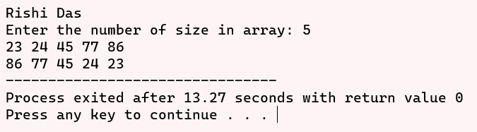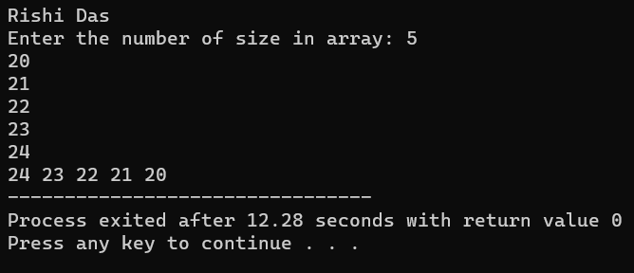

#PROGRAM 46

Program to perform Matrix operation (switch-case): Addition, subtraction, multiplication, and transpose

#include<stdio.h>

#define ROW 2

#define COL 2

void addmatrix(int matrix_a[ROW][COL],int matrix_b[ROW][COL]);

void submatrix(int matrix_a[ROW][COL],int matrix_b[ROW][COL]);

void multiplymatrix(int matrix_a[ROW][COL],int matrix_b[ROW][COL]);

void transposematrix(int matrix_a[ROW][COL],int matrix_b[ROW][COL]);

int main()

{

int matrix_a[ROW][COL],i,j;

int matrix_b[ROW][COL];

int operation;

printf("Rishi Das\n");

printf("Enter the matrix a: \n");

for (i=0; i<ROW; i++)

{

for(j=0; j<COL; j++)

{

scanf("%d",&matrix_a[i][j]);

}

}

printf("Enter the matrix b: \n");

for (i=0; i<ROW; i++)

{

for(j=0; j<COL; j++)

{

scanf("%d",&matrix_b[i][j]);

}

}

printf("Enter your choice: ");

scanf("%d",&operation);

switch (operation)

{

case 1:

addmatrix(matrix_a,matrix_b);

break;

case 2:

submatrix(matrix_a,matrix_b);

break;

case 3:

multiplymatrix(matrix_a,matrix_b);

break;

case 4:

transposematrix(matrix_a,matrix_b);

break;

default:

printf("Invalid choice enter");

}

return 0;

}

void addmatrix(int matrix_a[ROW][COL],int matrix_b[ROW][COL])

{

int resultmatrix[ROW][COL];

int i,j;

for (i=0; i<ROW; i++)

for(j=0; j<COL; j++)

resultmatrix[i][j]=matrix_a[i][j]+ matrix_b[i][j];

printf("Addition of matrix is: \n");

for (i=0; i<ROW; i++)

{

for(j=0; j<COL; j++)

{

printf("%d ",resultmatrix[i][j]);

}

printf("\n");

}

return;

}

void submatrix(int matrix_a[ROW][COL],int matrix_b[ROW][COL])

{

int resultmatrix[ROW][COL];

int i,j;

for (i=0; i<ROW; i++)

for(j=0; j<COL; j++)

resultmatrix[i][j]=matrix_a[i][j]- matrix_b[i][j];

printf("Subtraction of matrix is: \n");

for (i=0; i<ROW; i++)

{

for(j=0; j<COL; j++)

{

printf("%d ",resultmatrix[i][j]);

}

printf("\n");

}

return;

}

void multiplymatrix(int matrix_a[ROW][COL],int matrix_b[ROW][COL])

{

int resultmatrix[ROW][COL];

int i,j,k;

for (i=0; i<ROW; i++)

for(j=0; j<COL; j++)

{

resultmatrix[i][j]=0;

for(k=0; k<COL; k++)

resultmatrix[i][j]+=matrix_a[i][k]* matrix_b[k][j];

}

printf("Multiply of matrix is:\n ");

for (i=0; i<ROW; i++)

{

for(j=0; j<COL; j++)

{

printf("%d ",resultmatrix[i][j]);

}

printf("\n");

}

return;

}

void transposematrix(int matrix_a[ROW][COL],int matrix_b[ROW][COL])

{

int transposematrix_a[ROW][COL];

int transposematrix_b[ROW][COL];

int i,j;

for (i=0; i<ROW; i++)

for(j=0; j<COL; j++)

transposematrix_a[i][j]=matrix_a[j][i];

printf("Transpose Result of matrix a is: \n");

for (i=0; i<ROW; i++)

{

for(j=0; j<COL; j++)

{

printf("%d ",transposematrix_a[i][j]);

}

printf("\n");

}

for (i=0; i<ROW; i++)

for(j=0; j<COL; j++)

transposematrix_b[i][j]=matrix_b[j][i];

printf("Transpose Result of matrix b is: \n");

for (i=0; i<ROW; i++)

{

for(j=0; j<COL; j++)

{

printf("%d ",transposematrix_b[i][j]);

}

printf("\n");

}

return;

}

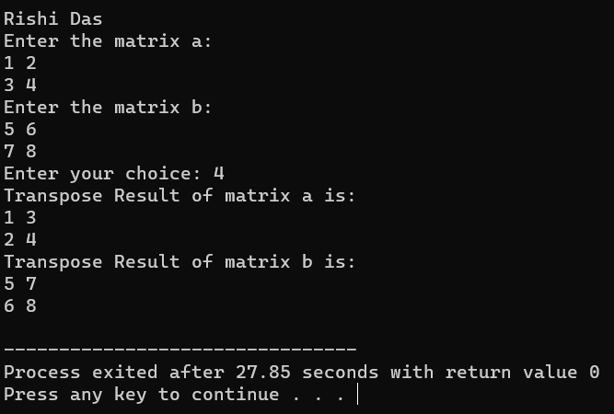

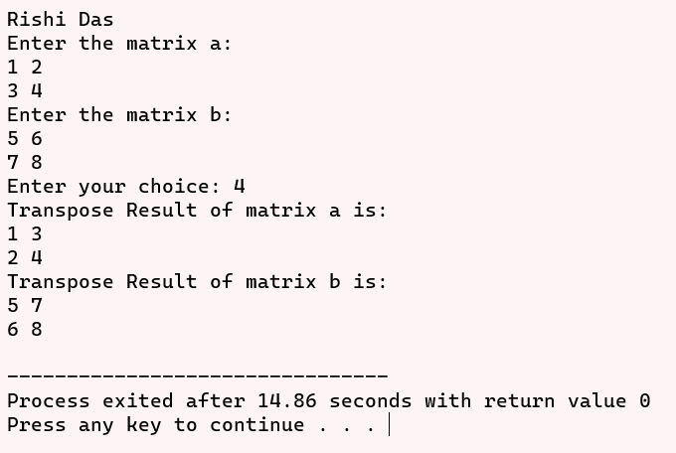

#PRACTICAL 47

Program to read character array using getchar() in do-while loop and print it. Find its length and number of vowels(case sensitive)

#include<stdio.h>

int main()

{

printf("Rishi Das\n");

char ch,name[10];

int len=0,vowel=0,i;

printf("Enter String: ");

do

{

ch=getchar();

name[len]=ch;

len++;

if(ch=='a'||ch=='e'||ch=='i'||ch=='o'||ch=='u'||ch=='A'||ch=='E'||ch=='I'||ch=='O'||ch=='U')

vowel++;

}

while(ch!='\n'&& len<10);

printf("The character array entered is: ");

for ( i = 0; i < len ; i++)

{

printf("%c ", name[i]);

}

printf("\n");

printf("String length is %d\n",len-1);

printf("Vowel in string is %d\n",vowel);

return 0;

}

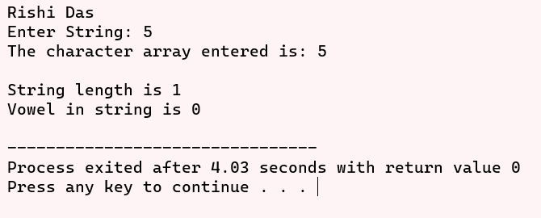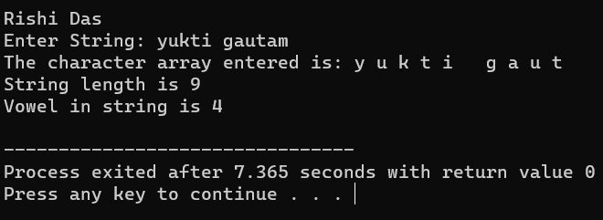

#PRACTICAL 48

Program to find the reverse of string (Without inbuilt function).

#include<stdio.h>

int main()

{

char name[1000],rev_name[1000];

int i=0,j,count=0;

printf("Rishi Das\n");

printf("Enter the name: ");

gets(name);

while(name[i]!='\0')

i++;

count=i-1;

for(j=0;j<i;j++)

{

rev_name[j]=name[count];

count--;

}

rev_name[j]='\0';

printf("Reverse name is %s",rev_name);

return 0;

}

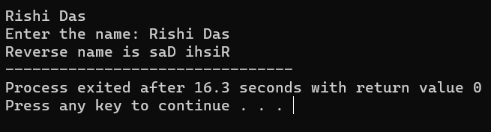

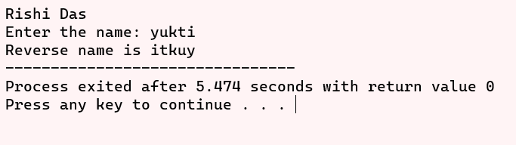

#Practical 49

Program to compare and concatenate two strings (Without inbuilt function).

#include<stdio.h>

int main()

{

char name[100],an_name[100];

int i=0,j;

printf("Rishi Das\n");

printf("Enter the name: ");

gets(name);

printf("Enter the another name: ");

gets(an_name);

for(i=0; name[i]!='\0'&& an_name[i]!='\0'; i++)

{

if(name[i]!=an_name[i])

{

printf("Strings are not equal\n");

break;

}

}

if(name[i]=='\0'&& an_name[i]=='\0')

printf("Strings are equal\n");

else

{

printf("Strings are not equal\n");

}

i=0;

while(name[i]!='\0')

i++;

for(j=0; an_name[j]!='\0'; j++)

{

name[i]=an_name[j];

i++;

}

name[i]='\0';

printf("%s\n",name);

printf("%s\n",an_name);

return 0;

}

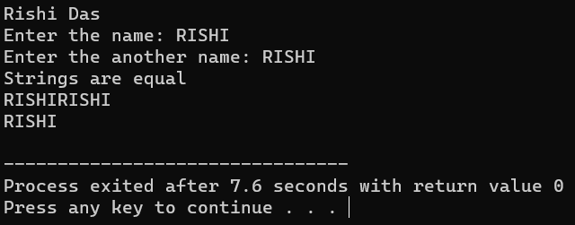

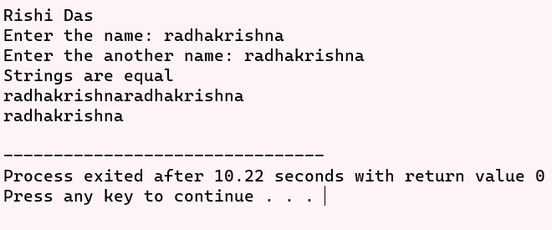

#PRACTICAL 50

Program to copy a string to another strings (Without inbuilt function)

#include<stdio.h>

int main()

{

char name[100],an_name[100];

int i;

printf("Rishi Das\n");

printf("Enter the name: ");

gets(name);

for(i=0; an_name[i]!='\0'; i++)

{

an_name[i]=name[i];

}

an_name[i] = '\0';

printf("Original String: %s\n",name);

printf("Copied String: %s\n",an_name);

return 0;

}

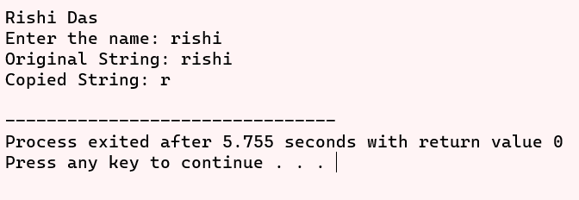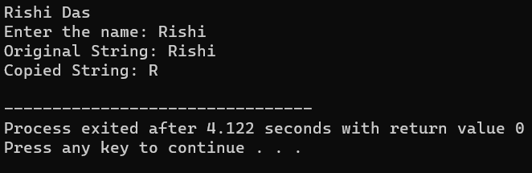

#PRACTICAL 51

Program to show the use of string function: strcpy(), strcat(), strcmp(), strlen().

#include<stdio.h>

#include<string.h>

int main()

{

char name[100],an_name[100],copy_name[100];

printf("Rishi Das\n");

printf("Enter the name: ");

gets(name);

printf("%d is the length of the string %s",strlen(name),name);

printf("\nEnter the another name: ");

gets(an_name);

printf("%d is the length of the string %s",strlen(an_name),name);

printf("\nCopy string is %s",strcpy(copy_name,name));

printf("\nConcatenate string is %s",strcat(name,an_name));

printf("\nReturn value of string is %d",strcmp(name,an_name));

return 0;

}

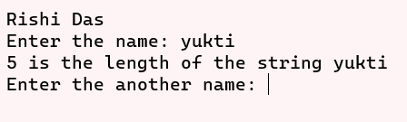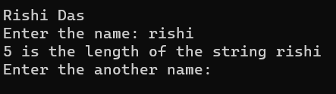

#PRACTICAL 52

Program to find string is palindrome or not

#include<stdio.h>

int main()

{

char name[1000],rev_name[1000];

int i=0,j,count=0,z;

printf("rishi\n");

printf("Enter the name: - ");

gets(name);

while(name[i]!='\0')

i++;

count=i-1;

for(j=0;j<i;j++)

{

rev_name[j]=name[count];

count--;

}

rev_name[j]='\0';

printf("Reverse name is %s",rev_name);

int flag = 1;

for(z=0; z<i; z++)

{

if(rev_name[z] != name[z])

{

flag = 0;

break;

}

}

if(flag)

{

printf("\nIt is a palindrome string\n");

}

else

{

printf("\nIt is not a palindrome string\n");

}

return 0;

}

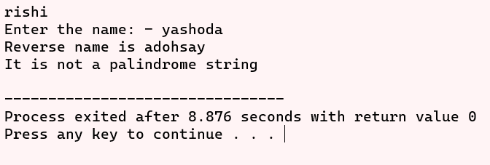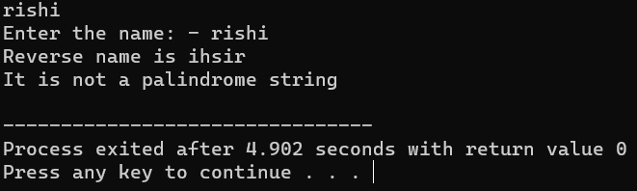

#PRACTICAL 53

Program to define pointers variables for int, char and float. Print their values (using*) and print their address.

#include<stdio.h>

int main()

{

printf("rishi\n");

int num ,*i;

float num1,*f;

char str[10],*d;

printf("Enter integer: ");

scanf("%d",&num);

printf("Enter float: ");

scanf("%f",&num1);

printf("Enter character: ");

scanf("%s",str);

i=&num;

f=&num1;

d=str;

printf("%d is on the address of %u\n",*i,&num);

printf("%f is on the address of %u\n",*f,&num1);

printf("%s is on the address of %u\n",d,&str);

return 0;

}

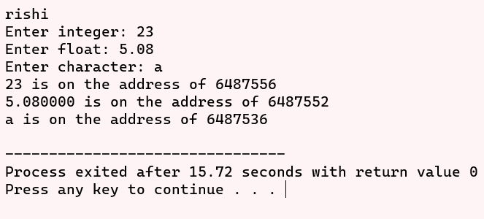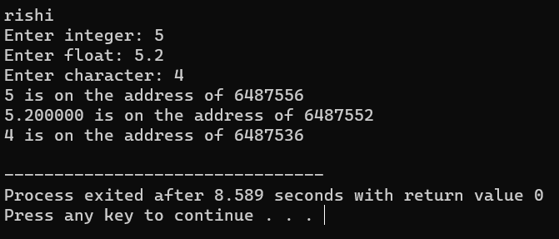

#PRACTICAL 54

Program to use pointers to read arrays element and find their sum

#include<stdio.h>

int main()

{

printf("Rishi\n");

int n, i,sum=0,*p;

printf("Enter the size of an array: ");

scanf("%d",&n);

int arr[n];

printf("Enter elements in array: ");

p=arr;

for (i=0; i<n; i++)

{

scanf("%d",&arr[i]);

sum+=*p;

p++;

}

printf("Sum is %d",sum);

return 0;

}

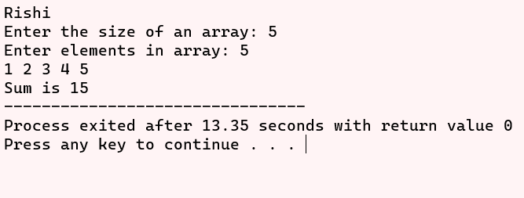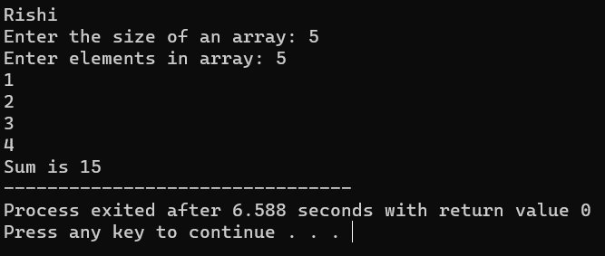

#PRACTICAL 55

Program to find length of string using pointers.

#include<stdio.h>

int main()

{

printf("Rishi das\n");

char str[100],*p;

int l=0;

gets(str);

p=str;

while(*p!='\0')

{

*p++;

l++;

}

printf("%d is the length of the String",l);

return 0;

}

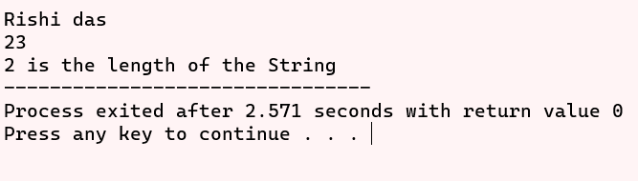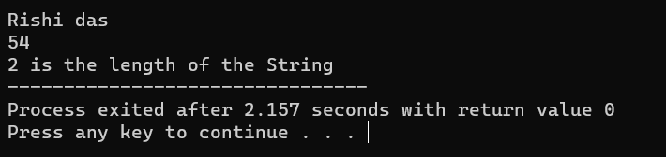

#PRACTICAL 56

Program to declare an array of pointers, read values and print them.

#include<stdio.h>

int main()

{

printf("Rishi das\n");

int n, i;

printf("Enter the size of an array: ");

scanf("%d",&n);

int arr[n],*p[n];

for(i=0;i<n;i++)

{

p[i]=&arr[i]; // Enter address of array to pointer

}

printf("Enter the elements in pointer");

for (i=0; i<n; i++)

{

scanf("%d",p[i]);

}

printf("Print the elements of pointer");

for (i=0; i<n; i++)

{

printf("%d\n",*p[i]);

}

return 0;

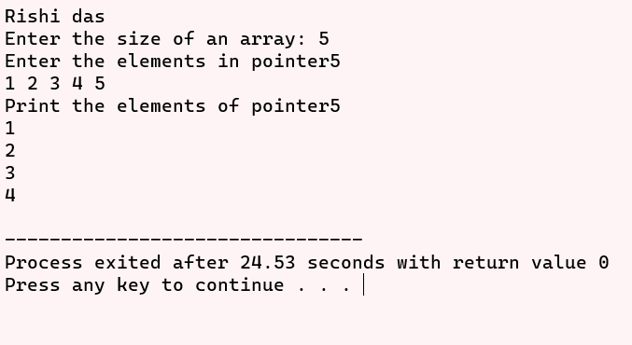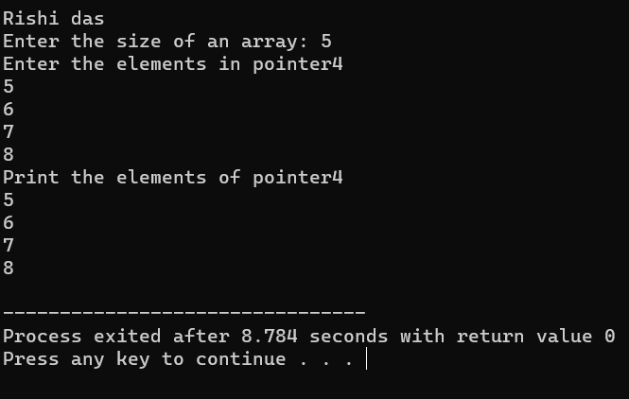

#PRACTICAL 57

Program to enter book records, using structures.

#include<stdio.h>

struct book

{

int page;

int lesson;

char book_name[20];

char book_type[10];

};

int main()

{

printf("Rishi das\n");

struct book book1,book2;

printf("Enter page number and lesson number in book 1: ");

scanf("%d %d",&book1.page,&book1.lesson);

printf("\nEnter book name book 1: ");

scanf("%s",book1.book_name);

printf("\nEnter book type of book 1: ");

scanf("%s",book1.book_type);

printf("\nEnter page number and lesson number in book 2: ");

scanf("%d %d",&book2.page,&book2.lesson);

printf("\nEnter book name book 2: ");

scanf("%s",book2.book_name);

printf("\nEnter book type of book 2: ");

scanf("%s",book2.book_type);

printf("Record of book 1 \nPage no. %d\nLesson no. %d\nBook name %s\nBook type %s\n",book1.page,book1.lesson,book1.book_name,book1.book_type);

printf("Record of book 2 \nPage no. %d\nLesson no. %d\nBook name %s\nBook type %s",book2.page,book2.lesson,book2.book_name,book2.book_type);

return 0;

}

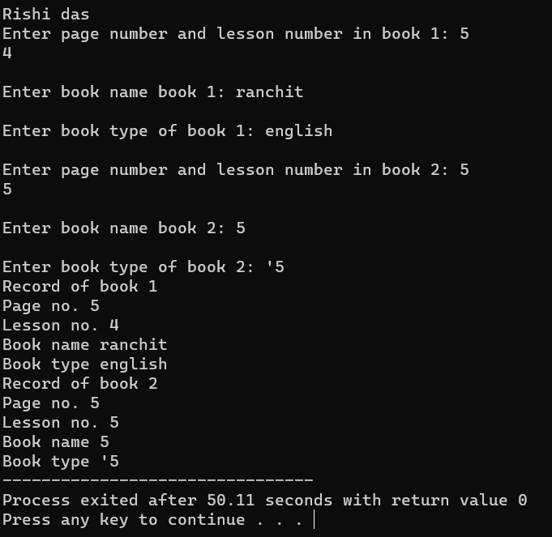

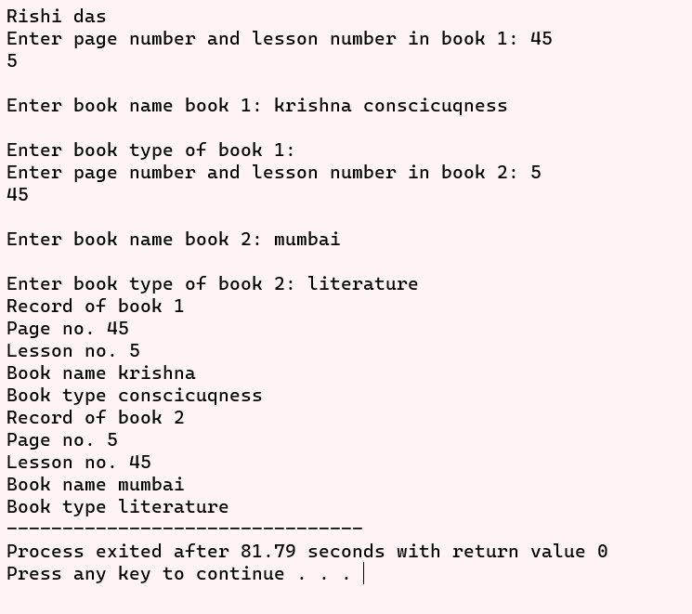

#PRACTICAL 58

Program to enter employee salary records, using structures. Create array of structures.

#include<stdio.h>

struct employee

{

int empid;

int salary;

char emp_name[20];

};

int main()

{

int employee_number,i;

printf("Rishi Das\n");

printf("Enter the number of employee: ");

scanf("%d",&employee_number);

struct employee employe[employee_number];

for(i=0;i<employee_number;i++)

{

printf("Enter the employee id: ");

scanf("%d",&employe[i].empid);

printf("\nEnter the employee salary: ");

scanf("%d",&employe[i].salary);

printf("\nEnter employee name: ");

scanf("%s",employe[i].emp_name);

}

printf("\nEmployee Records:\n");

for (int i = 0; i < employee_number; i++) {

printf("\nDetails of employee %d:\n", i + 1);

printf("Name: %s\n", employe[i].emp_name);

printf("Employee ID: %d\n", employe[i].empid);

printf("Salary: %d\n", employe[i].salary);

}

return 0;

}

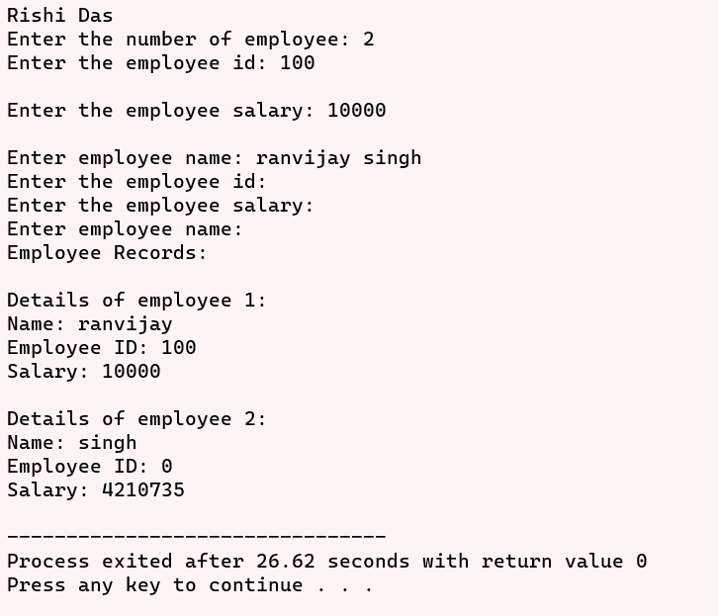

#PRACTICAL 59

Program to define a structure stores and write function update() to change the value of its member. Pass structure to update() and return structure.

#include<stdio.h>

struct data

{ int value;

};

struct data update(struct data new_data);

int main()

{

printf("Rishi Das\n");

struct data old;

scanf("%d",&old.value);

printf("Old value is %d\n",old.value);

old=update(old);

printf("Update value is %d\n",old.value);

return 0;

}

struct data update(struct data new_data)

{ int n_value;

scanf("%d",&n_value);

new_data.value=n_value;

return new_data;

}

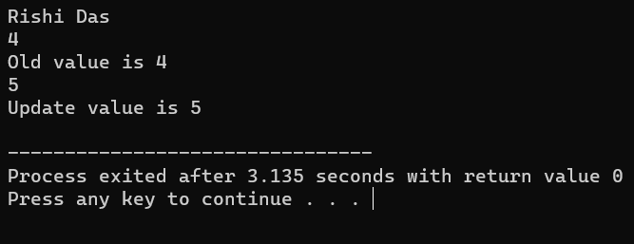

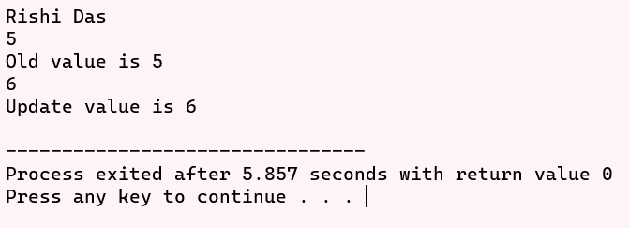

#PRACTICAL 60

Program to open a file, read character data from keyboard and write it into the file. Close the file and reopen it to print the contents.

#include<stdio.h>

int main()

{

FILE *f1;

char c;

printf("Rishi Das\n");

printf("Data Input\n\n");

f1 = fopen("INPUT.txt", "w");

while((c=getchar()) != '\n')

putc(c,f1);

fclose(f1);

printf("\nData Output\n\n");

f1 = fopen("INPUT.txt","r");

while((c=getc(f1)) != EOF)

printf("%c",c);

printf("\n");

fclose(f1);

return 0;

}

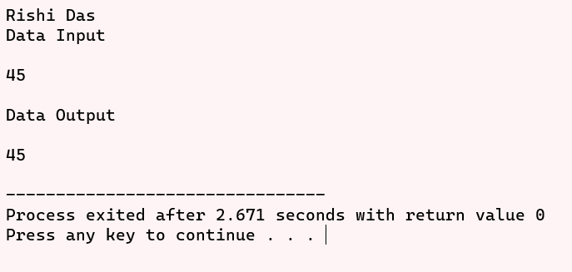

#PRACTICAL 61

Program to open a file, read integer data from keyboard and write it into the file. Close the file and reopen it to print the contents.

#include<stdio.h>

int main()

{

FILE *f1;

int n,i;

printf("Rishi Das\n");

printf("Data Input\n\n");

f1 = fopen("Input number.txt", "w");

for(i=1;i<=10;i++)

{

scanf("%d",&n);

putw(n,f1);

}

fclose(f1);

printf("\nData Output\n\n");

f1 = fopen("Input number.txt","r");

while((n=getw(f1)) != EOF)

printf("%d ",n);

printf("\n");

fclose(f1);

return 0;

}

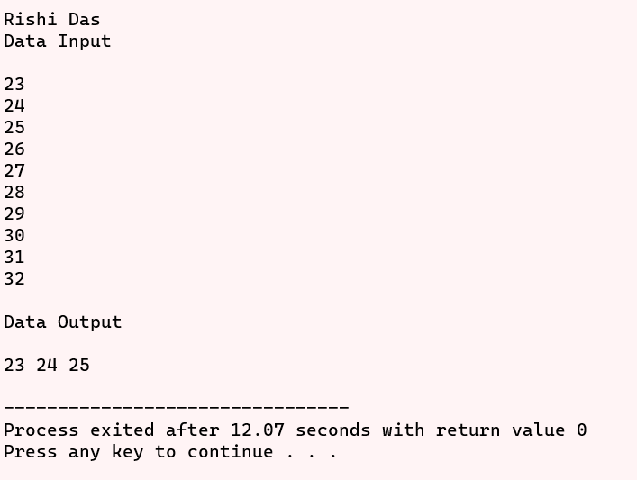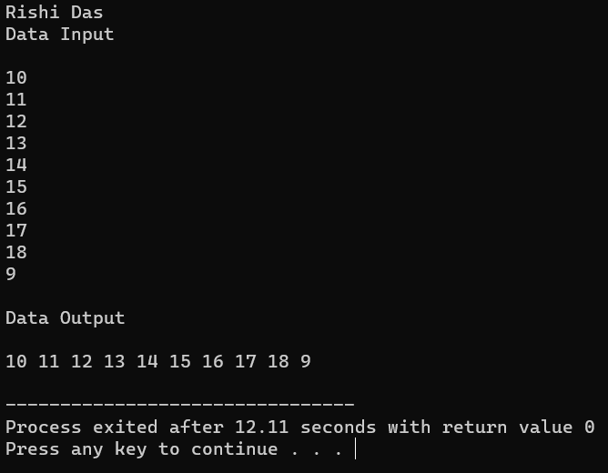

#PRACTICAL 62

Program to demonstrate use of malloc() and free().

#include<stdio.h>

#include<stdlib.h>

int main()

{

int n,*arr;

printf("Rishi Das\n");

printf("Enter the number of elements: ");

scanf("%d", &n);

arr = (int *)malloc(n * sizeof(int));

if (arr == NULL)

{

printf("Memory allocation failed.\n");

return 1;

}

printf("Enter %d integers:\n", n);

for (int i = 0; i < n; ++i)

{

scanf("%d", &arr[i]);

}

printf("Entered integers are: ");

for (int i = 0; i < n; ++i)

{

printf("%d ", arr[i]);

}

printf("\n");

free(arr);

return 0;

}

